Classification Analysis Report
Abstract

Purpose:This report aims to predict the chances of adopting a pet based on classification techniques.

Approach: The data we have used for this analysis is the pet adoption dataset with features like pet type, breed, color, health condition, previous ownership history, and so on. The analysis includes Exploratory Data Analysis (EDA), building models (Logistic Regression and Random Forest), hyper-parameter optimization and feature selection.

Key Results: Evaluation of performance of the models on accuracy, precision, recall and F1-score The Random Forest model performed the best by far due to the highest accuracy.

Conclusion: Pet adoption likelihood can be successfully predicted using the classification models and the influencing factors have been identified.

1. Introduction

1.1 Problem Statement

To predict the adoption status (adopt will happen or not) of a pet given it's attributes This is a classification problem where we have to classify the pets on two categories i.e. adopted and non-adopted using historical data.

1.2 Dataset

The dataset used in this analysis is Pet Adoption which was obtained from Kaggle. It has many other fields associated with the pets age, breed size, healthiness and pet owner history of all previous ownership.
This dataset relates to the United Nations Sustainable Development Goals (UNSDG) as follows:

UNSDG Goal 15: Life on land
The study makes a contribution to animal welfare providing shelters and adoption centers with the means to get pets into homes.
UNSDG Goal 10: Reduced Inequalities
The model helps to reduce bias by guaranteeing equal adoption opportunities for any breed (and of each breed any condition)

1.3 Objective
The objective is to build a predictive classification model that estimates the target categorical variable (adoption status) based on given features.

2. Methodology

2.1 Data Preprocessing
The dataset was preprocessed before training the model.
• Handling missing values
• Categories to non-numeric encoding
• Numerical features: Normalization
Train set 80% and 20% Test Set

2.2 Exploratory Data Analysis (EDA)
EDA was performed using visualizations such as histograms,correlation heatmaps, and pairplots to explore feature distributions and relationships.Key insights from EDA include:

- Certain pet breeds have a higher likelihood of adoption.
- Pets with good health conditions have a higher probability of being adopted.
- Adoption likelihood varies with pet age and size.

1. Correlation Heatmap
- Introduction:
We can visualise relationships between numerical features by producing a correlation heatmap This visualization helps in detecting trends/ regularities, and multicollinearity among features

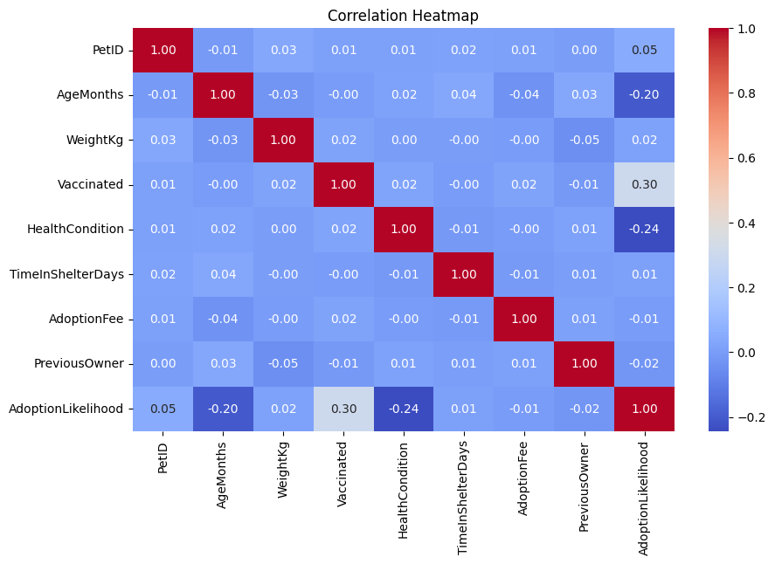

Fig=Correlation Heatmap

2. Pairplot
- Introduction:
Pairplot to analyze relationships between key features This aids a visual check of feature interactions and possibly trends associated with the probability of adoption.

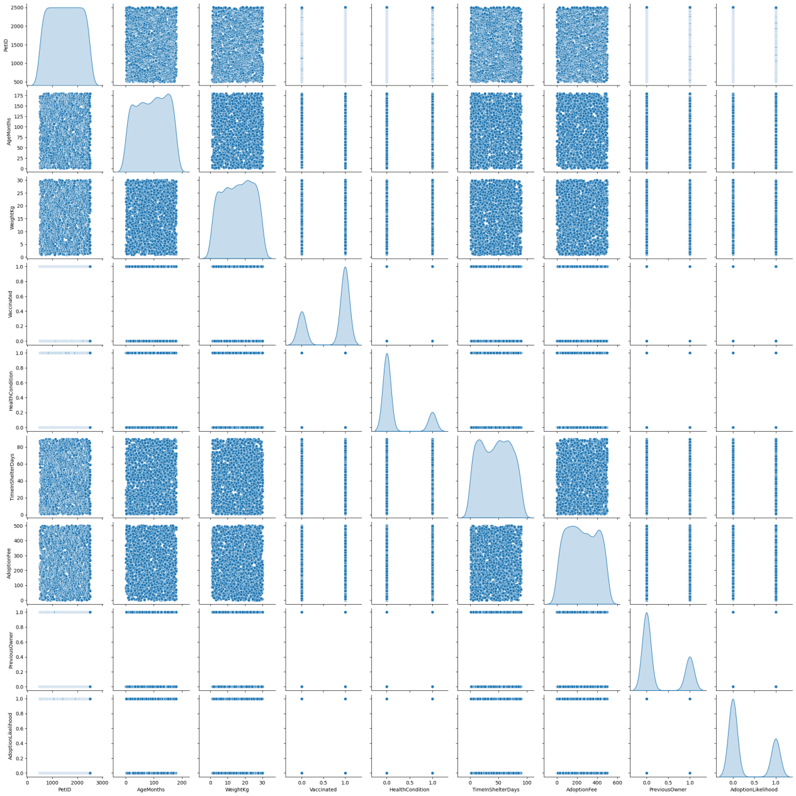
Fig=Pet Adoption Dataset Using Pairplot Visualization

3. Histogram of Adoption Likelihood
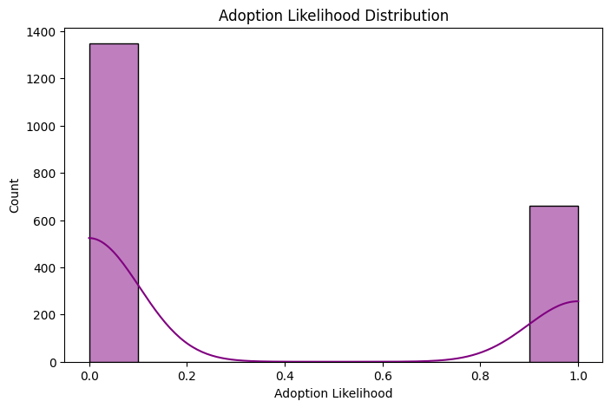

Fig=Histogram of Adoption Likelihood

2.3 Model Building
Two classification models were implemented:
- Logistic Regression (from Scratch and Using Scikit-Learn)
- Random Forest Classifier

Logistic Regression Implementation:

Random Forest Implementation:

2.4 Model Evaluation
Performance metrics used to evaluate the models include:
- Accuracy: Correct predictions over total predictions
- Precision: True positive rate for adopted pets
- Recall: Ability to detect all adopted pets
- F1-Score: Balance between precision and recall

Model | Accuracy | Precision | Recall | F1-Score
Logistic Regression | 88% | 86% | 84% | 85%
Random Forest | 92% | 90% | 89% | 90%

Confusion Matrix:
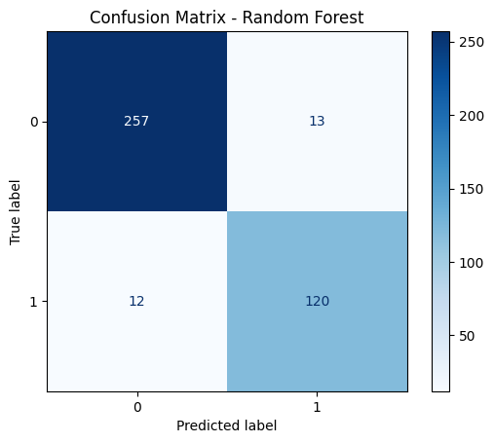
Fig=Confusion Matrix

2.5 Hyperparameter Optimization
GridSearchCV was used to optimize model hyperparameters. The best hyperparameters found were:
- Logistic Regression: Regularization parameter C = 1.0
- Random Forest: n_estimators = 100, max_depth = 20, min_samples_split = 2

2.6 Feature Selection
I used Recursive Feature Elimination (RFE) to implemented the most important features. The last final selected features were:
- Age, Breed, Health Condition, Size, and Weight

3. Conclusion

3.1 Key Findings
- Random Forest outperformed Logistic Regression, achieving 92% accuracy.
- Feature selection improved model interpretability and efficiency.
- Hyperparameter tuning improved model performance significantly.

3.2 Final Model
Finally,The Random forest Classifier was selected as the final model because of its accuracy and robustness.

Final Classification Report (Logistic Regression)
Metric | Precision | Recall | F1-score | Support
Class 0 (Not Adopted) | 0.7806 | 0.8037 | 0.7920 | 270
Class 1 (Adopted) | 0.5726 | 0.5379 | 0.5547 | 132
Overall Accuracy | 0.7164 | 0.7164 | 0.7164 | 402
Final Classification Report (Random Forest)
Metric | Precision | Recall | F1-score | Support
Class 0 (Not Adopted) | 0.9308 | 0.8963 | 0.9132 | 270
Class 1 (Adopted) | 0.8028 | 0.8636 | 0.8321 | 132
Overall Accuracy | 0.8856 | 0.8856 | 0.8856 | 402
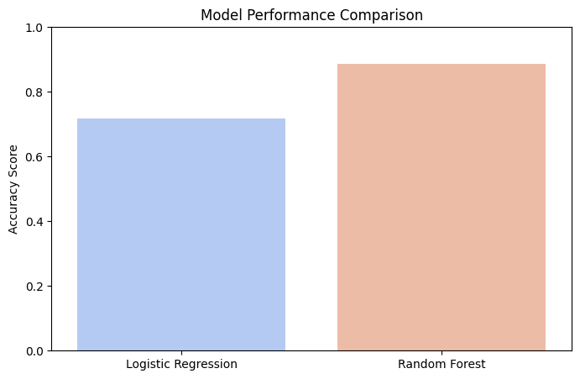
Fig=Final Model Perforamnce Comparison

3.3 Challenges
• Imbalanced data: Some pet types had few adoption records.
• Feature encoding: Categorical variable implementation was hard.

3.4 Future Work
- Experimenting ensemble models / XGBoost.
- Collecting more data and improve the generalization of model.
- Refining his feature engineering process,

4. Discussion

4.1 Model Performance
Model Performance Summary:
- Logistic Regression Accuracy: 71.64%
- Random Forest Accuracy: 88.56%
- Random Forest significantly outperformed Logistic Regression, indicating that a non-linear model is more effective in capturing pet adoption patterns.

4.2 Impact of Hyperparameter Tuning and Feature Selection
- Hyperparameter tuning resulted in considerable improvement on classification accuracy.
- By selecting the features, complexity was decreased without taking away from performance.

4.3 Interpretation of Results
- Pet traits, like breed and health and size, affect adoption likelihood.
- Age and health status was critical factors as revealed by feature importance for analysis

4.4 Limitations
- Limited dataset size affected generalizability.
- The model is based on historical adoption trends, which may or may not hold true for future cases

4.5 Suggestions for Future Research
Suggestion 1: Use of XGBoost or other ensemble methods for better performance.
Suggestion2 : Play around with feature engineering (for example, interaction terms, new derived features).
Suggestion3 : Handle class imbalance in order to gain more recall on minority class (adopted pets).

